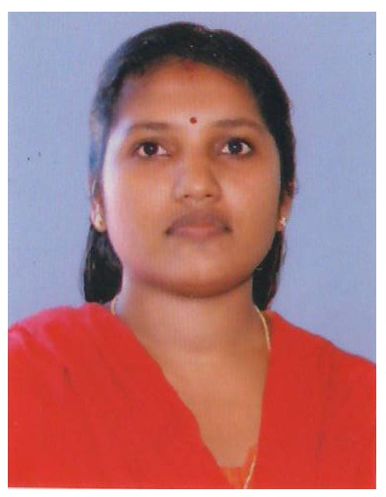

Photo

Name of the Teaching Staff | SUMI K S
Designation | Assistant Professor
Department | Dept. of Economics
Date of Birth | 28-04-1983 |  | Date of Joining the Institution |  |  |  | 05-03-2012
Educational Qualification | UG – BA Economics |  | PG – MA Economics |  |  |  |  |  | PhD –
Area of Interest | Micro Economics, Macro Economics
Total Experience | Teaching –4 Years |  | Industry – |  |  |  |  |  | Research –  One Year
No. of Papers Published in Journals | National - NIL |  | International - NIL
No. of Papers Presented in Conferences | National - 2 |  | International - NIL
No. of Seminars / Workshops Attended | National- 10 |  | International- NIL
Programs Conducted | Conference:  National :  International : |  | Seminar  National :  International : |  |  |  |  | Workshop -
Trainings attended | Orientation 1 | Refresher-1 |  | Technology –
Positions held at University Level | Board of Studies- |  |  | Curriculum Revision- |  | Subject Expert |  |  |  | Any Other-
PhD Guide? Give field & University | Field: |  | University :
No. of PhDs / Projects Guided | PhDs - |  | Projects at Masters Level:
Books Published / IPRs/ Patents | NIL
Professional Memberships | Member- Kerala Economic Association
Consultancy Activities | NIL
Awards | NIL
Grants fetched | Minor Projects 1.35 Lakhs |  |  |  | Major Projects
Interaction with Professional Institutions | NIL

Papers Presented in Conferences/ Seminars
- Presented a paper “Women Empowerment an overview” in the UGC Sponsored National Seminar on “Changing Status of Women in India –Its issues and Challenges” held at Morning Star Home Science College ,Angamali on 25th and 26th July 2013
- Presented a paper on “ Climate Change and Agriculture Sustainability “in the UGC Sponsored National Seminar “The Impact of Climate Change on India’s Agricultural Sector with Special Focus on Kerala Economy” on 29th and 30th September 2015
Seminars / Workshops Attended
- UGC Sponsored National Seminar “The Impact of Climate Change on India’s Agricultural Sector with Special Focus on Kerala Economy” on 29th and 30th September 2015 held at SNM College Maliankara
- UGC Sponsored National Seminar On “ Role of corporate Social Responsibility On Modern Business Era” ” held at SSV College Valayanchirangara on 6th and 7th August 2015.
- UGC Sponsored National Seminar on “Major Issues in Centre-State financial Relations in India” held at UC College Aluva,on 23rd and 24th October 2014.
- UGC Sponsored National Seminar on “Wake up! Lets Arise! Awake! And Stop Not Till the Goal is Reached” organised by SSV College on 25th and 26th September 2014
- UGC Sponsored National Conference on “Cyber Law and Cyber Forensics” held on 13th and 14th August, 2013 organised by the Department of Computer Science , SSV College, Valayanchirangara.
- National Seminar On Challenges of Economics in a Neo -Liberal Era: Methodology, Theory and Empirics, March 6th and 7th 2013 organised by Department of Economics, Panampilly Memorial Government College, Chalakudy
- UGC sponsored National Seminar on” Changing Status of Women in India –Its issues and Challenges” held at Morning Star Home Science College ,Angamali on 25th and 26th July 2013
- UGC sponsored Seminar on Music organised by the Department of Student Services in association with SSV College , Valayanchirangara, on 28th September 2012
- National Seminar on Capital Market and Economic Effiency held at UC College Aluva, 14th and 15th November, 2008.
- UGC sponsored National Seminar on “Human Rights and Values In Education” conducted at SNM College, Maliankara, on 9th to 11th August 2006

Minor Project
- Economics of Islamic Banking- An Enquiry into its Prospective Performance in Kerala funded by UGC

